**Group 7 - SDEV 220 - Final Project Launch**

This assignment is to prepare for the final project. This assignment will prepare us to collaborate with our classmates in order to be successful in completing our final project. There are 3 Steps below that we must complete in order to fulfill this assignment’s requirements.

**Step 1: Communication**

When working on a project, it is very important to communicate with our team members. We will be using Discord as our project manager to communicate with one another. Discord is a chat and video conferencing application that has chat logs and file uploads. Discord will also allow us to communicate asynchronous and work with our varying schedules.

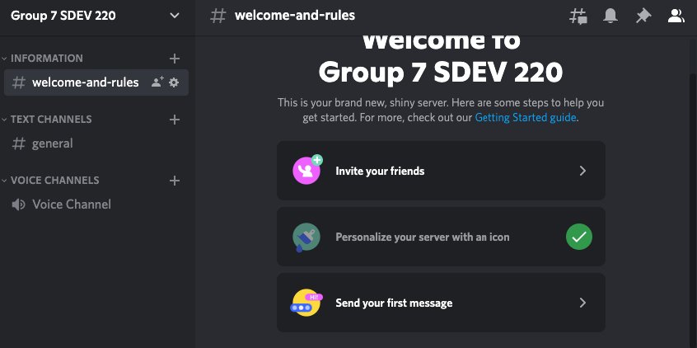

**Step 2: Project Description**

The Client: [Art Haus Balloon Company](https://arthausballooncompany.com/) is a small business that does balloon décor. In business since 2019, they are facing [many challenges](https://fox59.com/news/higher-prices-limited-services-among-side-effects-as-small-businesses-navigate-challenges/), including the ongoing inflation of materials and supplies. As costs fluctuate, they’ve had to ditch her set price list to accommodate the changes. Supply shortages have also limited the business, forcing them to seek different distributors for items that usually come easy, like basic colors of balloons to helium.

The Scope of the System: Our python program will keep track of the inventory and backup vendors. Additionally, it will take orders and provide customer pricing based on cost of materials.

The Purpose of the System: This system will allow Art Haus Balloon Company to stay up to date with the ongoing inflation of materials and have a current price list that accommodates the changes.

**Step 3 - Project Collaboration**

In order to collaborate for the final project, we have created a Github account. We will be using the collaboration features.

<https://github.com/MelissaBernadette/SDEV_220_Final_Project_Group7>

**Step 4 - Project Management and Roles**

During this project, we will assign individual roles to team members, and keep up with each other's feature implementations. Our roles will be assigned by breaking roles into implementing certain features of the project.

In order to keep track of our project, we will utilize one part of the Agile Project Management methodology known as Kanban Boards. We will be using the Trello board software in order to create a Kanban board for our team.

Our Trello Board: <https://trello.com/b/8ZGfVpyr/final-project>

* Describe each team members roles and responsibilities
  + Kira: Inventory, input inventory as supplies come in
  + Jaecob: Vendors and backup vendors, input vendor information and pricing
  + Melissa: Customer Orders, input orders reducing inventory, provide pricing based on inventory cost